**Vision Based Automation**

**Name: Vivek Chandrashekhar Rugale**

**GR No.: 11810369**

**Div.: TY-C**

**Roll No.: 24 (Batch B1)**

**Lab 1 :** Image Histogram Equalization

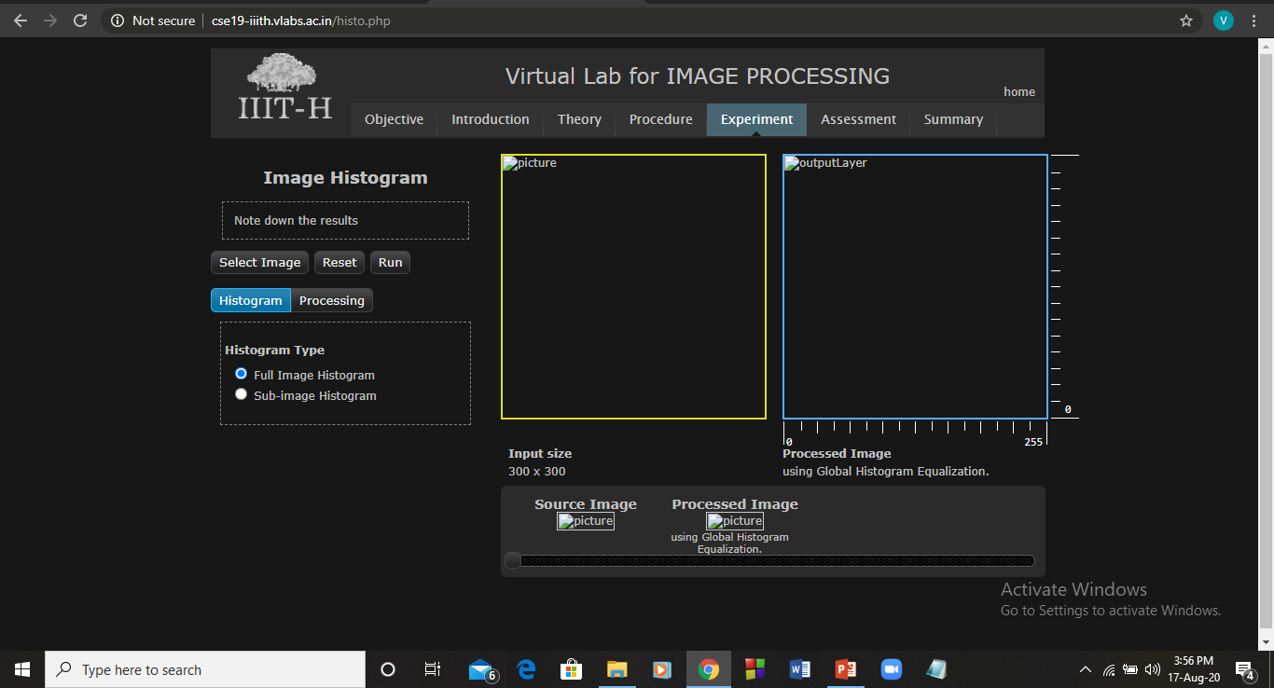

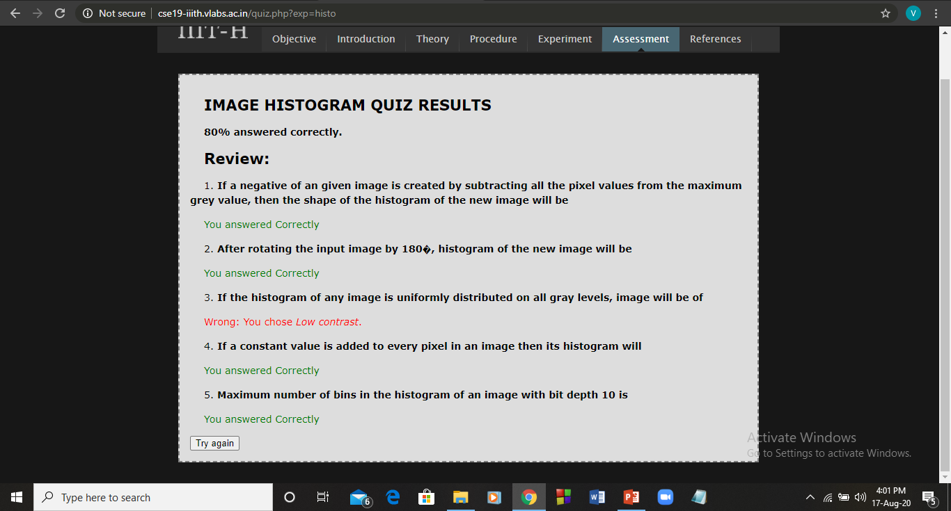

**Lab 2 :** Python code to read image and plot histogram

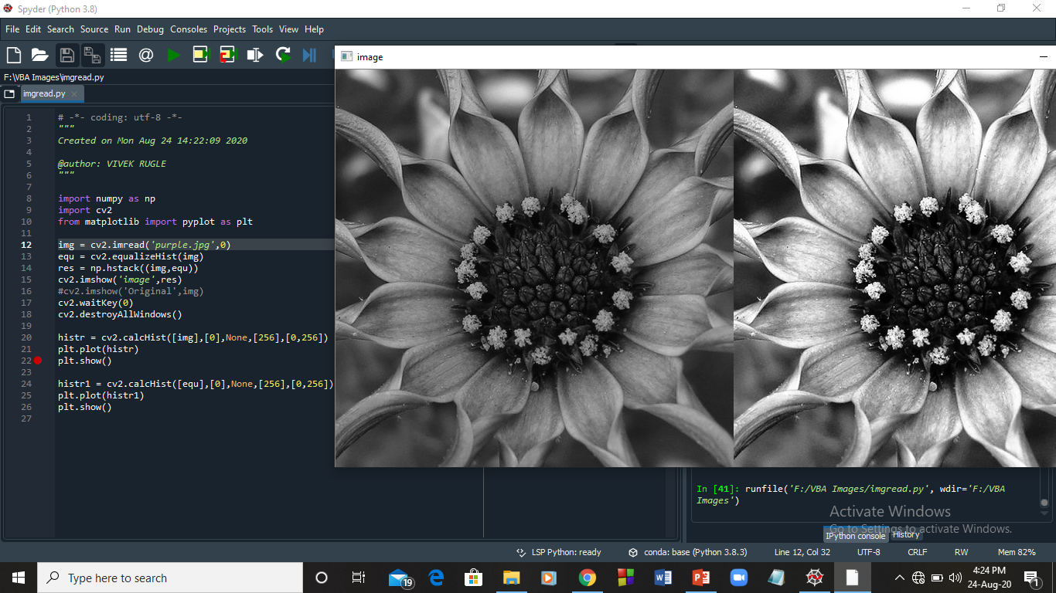

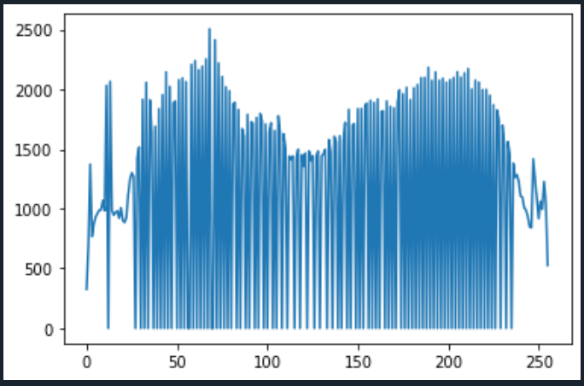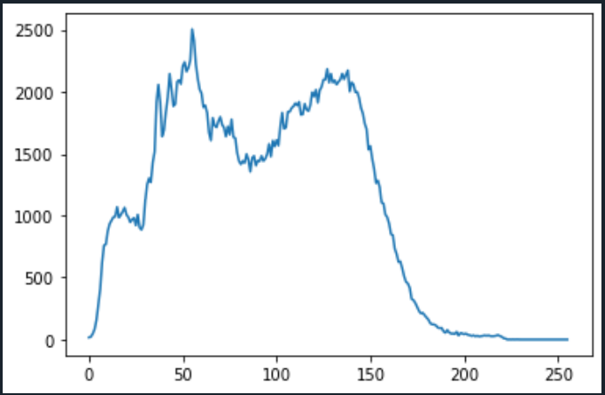

**Lab 3:** DFT of an image using open cv

* DFT of rectangle image -



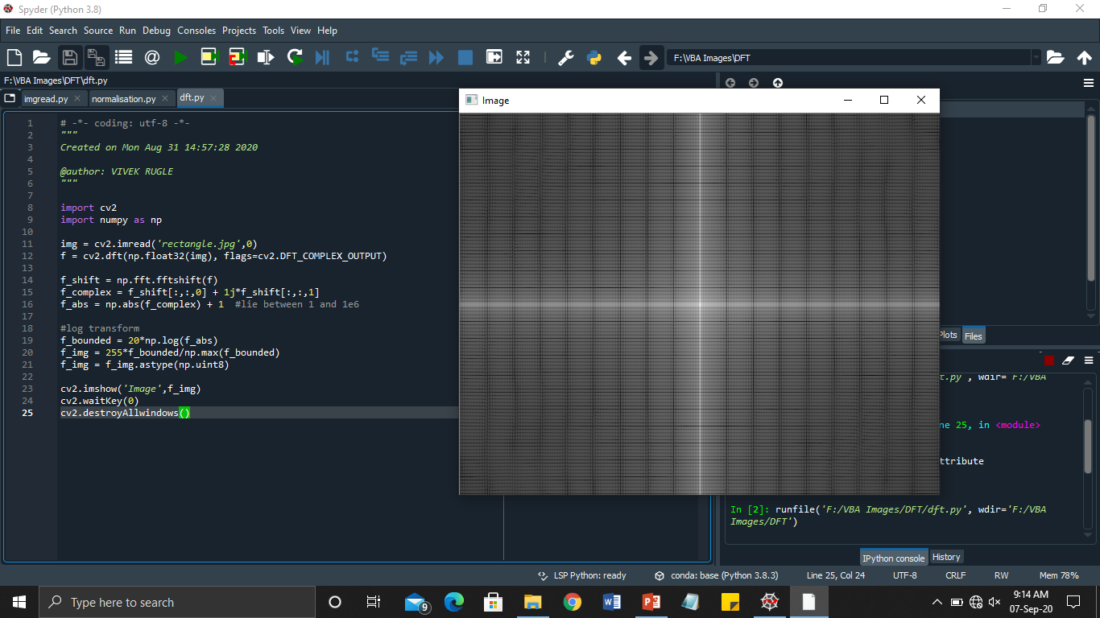

* For triangle and inclined line –

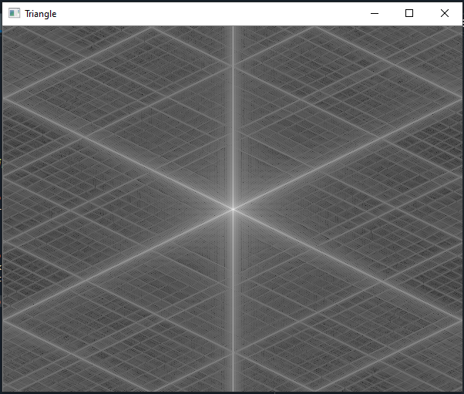 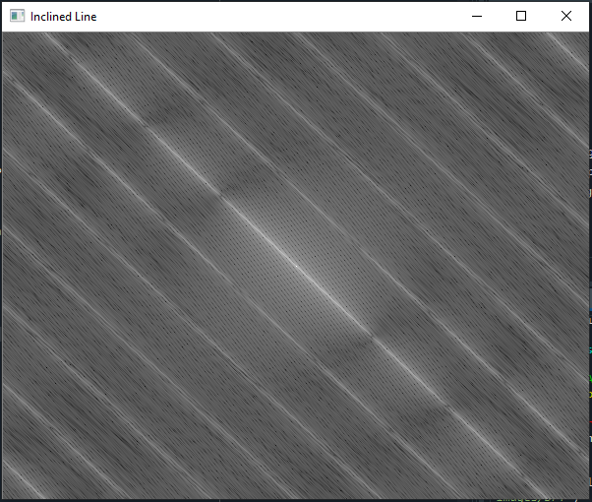

* For star and circle –

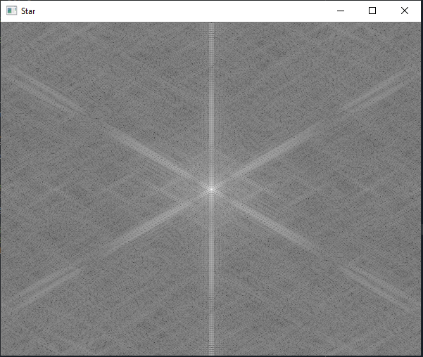 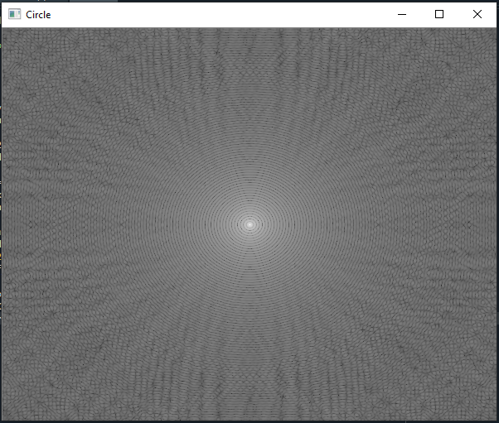

**Lab 4:** Edge detection using OpenCV

* Using Sobel operator -

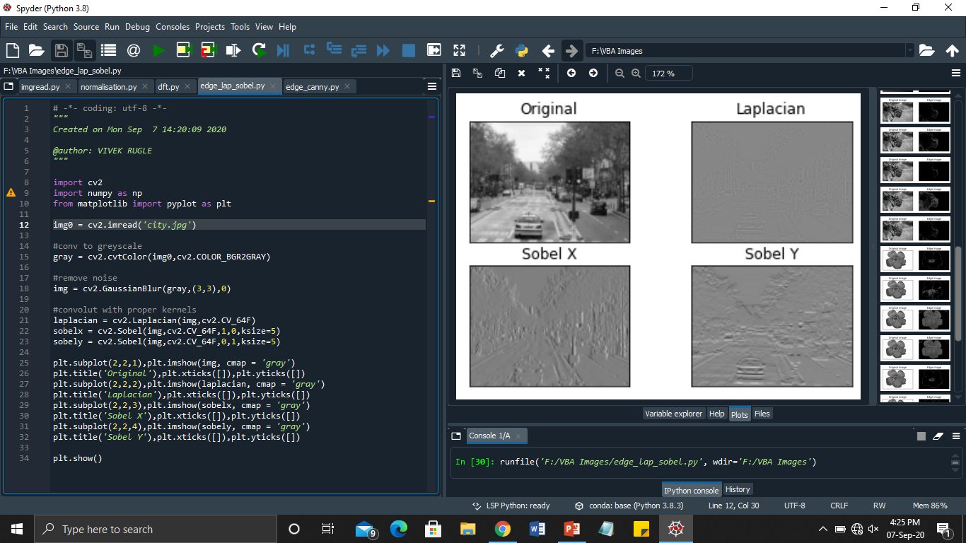

* Canny edge detection -

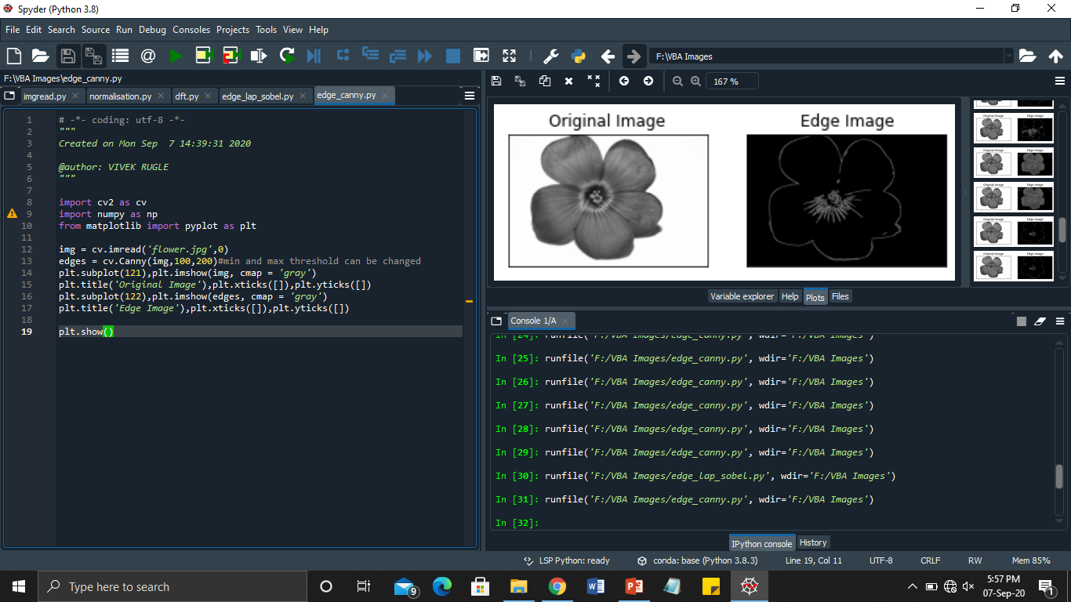

**Lab 5:** Low pass filtering of image

* Spatial Domain

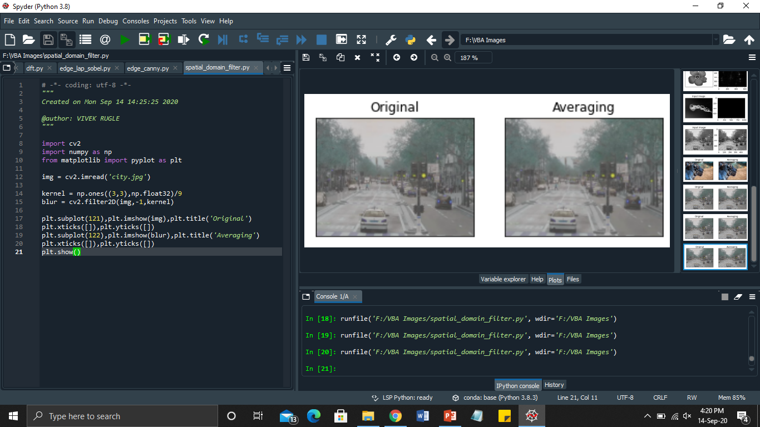

* Frequency Domain

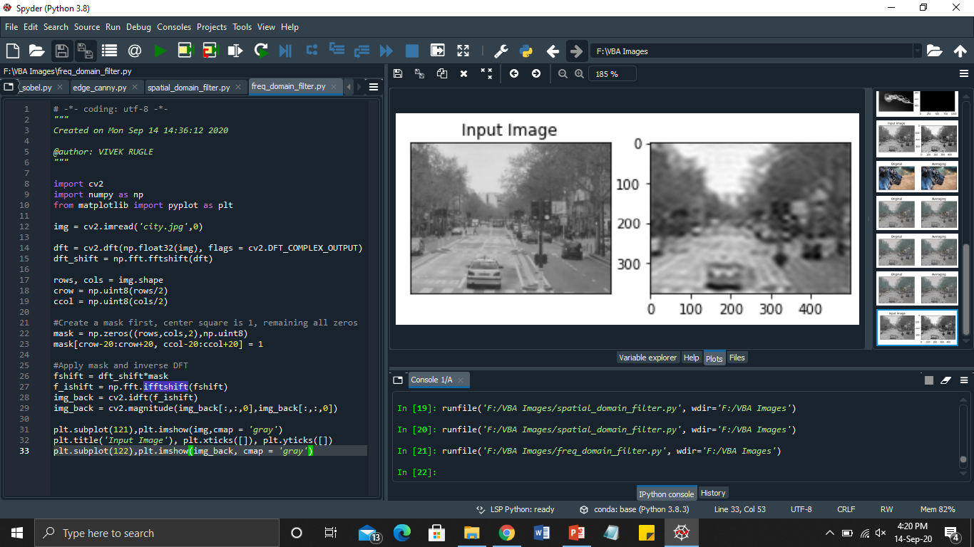

**Lab 6:** Image segmentation using opencv

1. Otsu Thresholding -

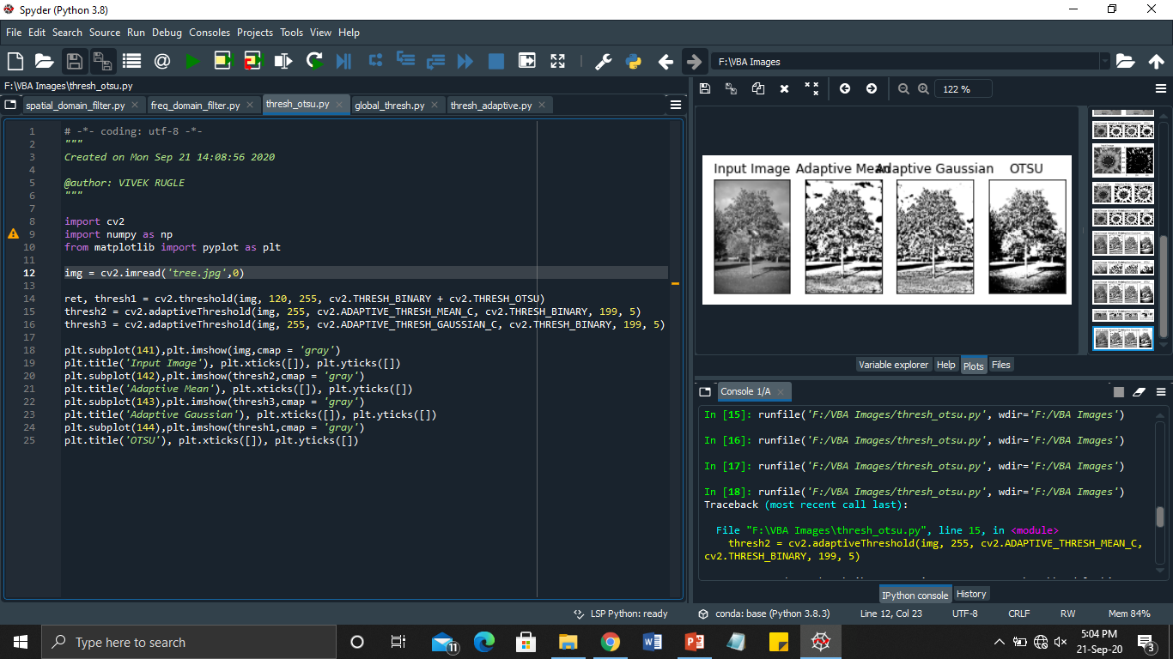

* Global Thresholding -

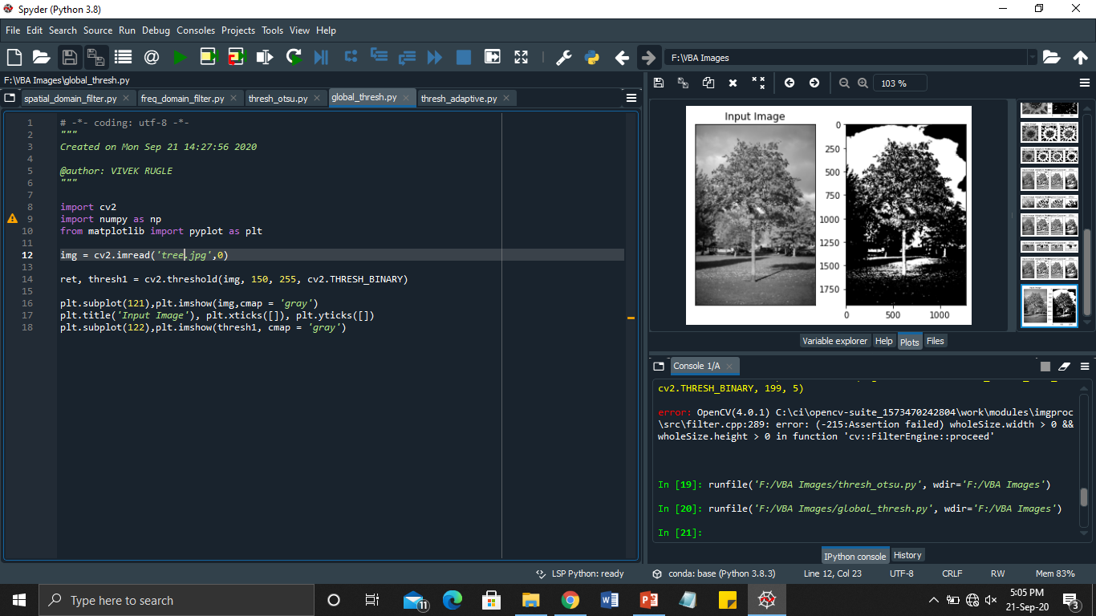

* Adaptive Thresholding

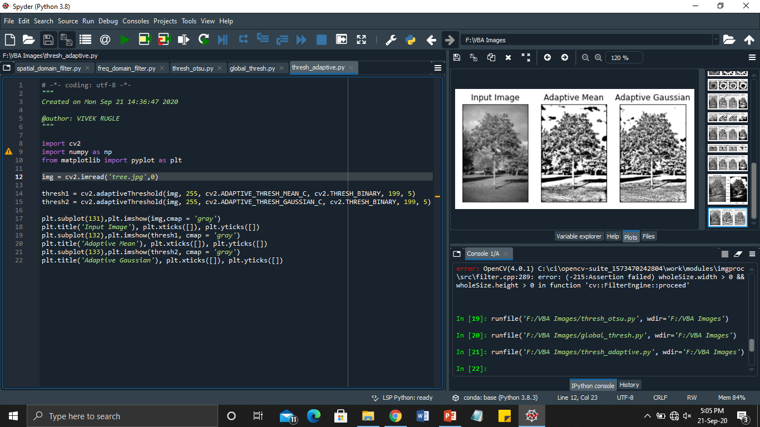

**Lab 7:** Scaling, rotation and translation of image using OpenCV

* Scaling -

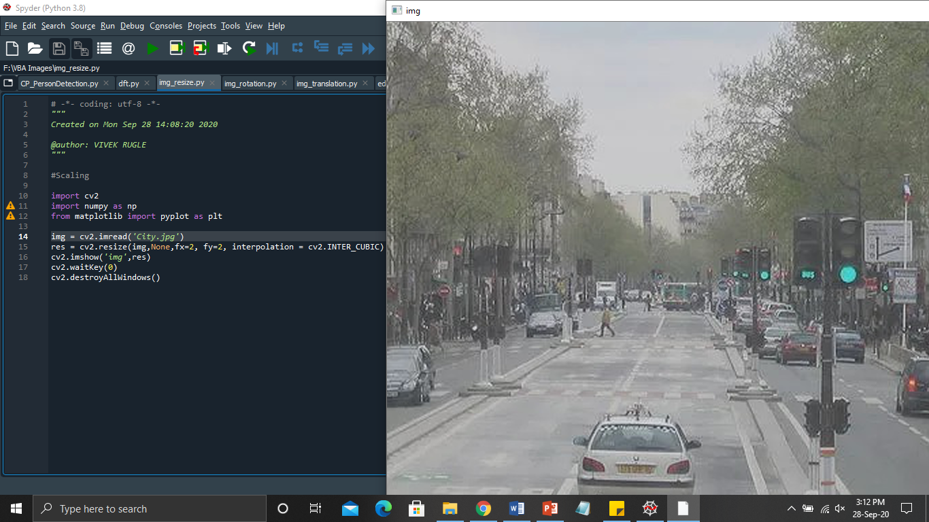

* Image rotation -

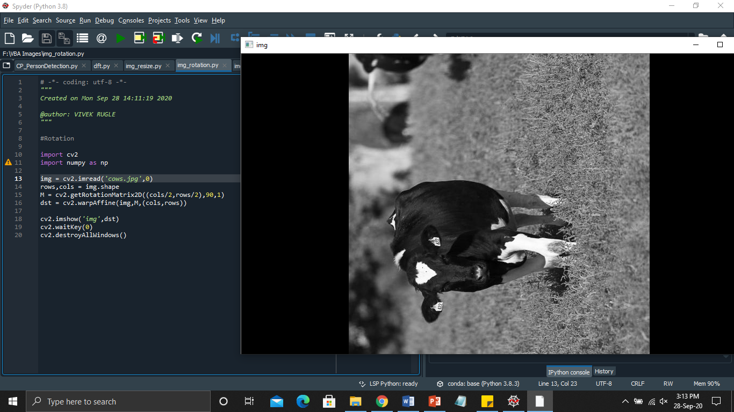

* Image translation -

